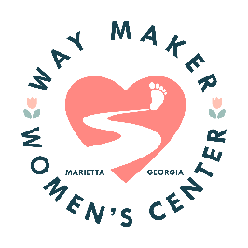 | 3956 Due West Road  Marietta, GA 30064
December 13, 2022
Dear Rotary Members,
We want to thank you for your continued support and generous donation of $1500.00 to Way Maker. You are helping us in so many ways and know that we do not take it for granted.
We will be using these funds to help provide our mothers with Christmas for their children and Christmas dinners. We will also be purchasing wipes, baby bath, lotion and other items that are depleted on a monthly basis.
Please continue to keep Way Maker and the women who come to this ministry for help in your prayers.
Many blessings,
The Staff of Women’s Ministry/Due West UMC
info@waymaker.center
Waymaker.center

